6 Pt. Bonus Challenge:
1 pt. for three accurate tape lines
1 pt. for stop at first line
1 pt. for stop at second line
1 pt. for stop at third line
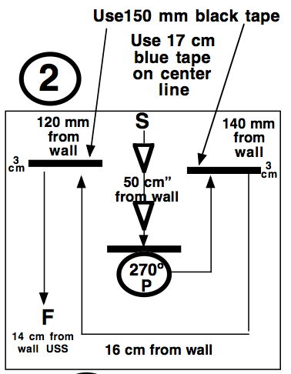
1 pt. for finish.

